May 23, 2025

|  |  |
| --- | --- |
| The Honorable Chairman Cole  Chairman, House Committee on  Appropriations  U.S. House of Representatives  Washington, DC 20515 | The Honorable Ranking Member DeLauro  Ranking Member, House Committee on  Appropriations  U.S. House of Representatives  Washington, DC 20515 |

Dear Chairman Cole and Ranking Member DeLauro,

I am requesting funding for the Native Village of Chenega Harbor Breakwater project in Fiscal Year 2026. The entity to receive funding for this project is the Native Village of Chenega, located at 3000 C Street, Anchorage, AK 99503.

This funding would be used to construct a wave attenuation breakwater, designed to protect an estimated 2,000 feet of shoreline. Safeguarding Chenega's coastal shoreline and harbor, which is essential for the community's long-term viability, including, by supporting the commercial fishing fleet. The use of wave attenuators is effective at dramatically reducing waves’ force and neutralizing surface energy.

The project is an appropriate use of taxpayer funds as this project will protect the community's small boat harbor, which is essential for economic, subsistence and cultural preservation. Chenega's economic sustainability is closely tied to maintaining access to fisheries resources, making the harbor's functionality vital for both residents and traditional practices. This initiative is a pivotal step toward ensuring the community's future, safeguarding its culture, and supporting economic growth in the community and region.

The project has a federal nexus because the funding provided is for purposes authorized by 23 USC 133. I certify that I have no financial interest in this project, and neither does anyone in my immediate family.

Sincerely,

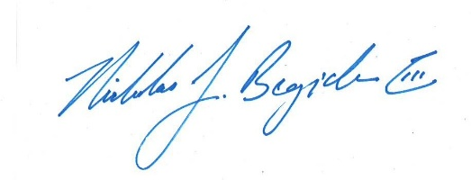

Nicholas J. Begich III

Congressman for All Alaska