May 23, 2025

|  |  |
| --- | --- |
| The Honorable Chairman Cole  Chairman, House Committee on  Appropriations  U.S. House of Representatives  Washington, DC 20515 | The Honorable Ranking Member DeLauro  Ranking Member, House Committee on  Appropriations  U.S. House of Representatives  Washington, DC 20515 |

Dear Chairman Cole and Ranking Member DeLauro,

I am requesting funding for Marydale Avenue Improvements in Fiscal Year 2026. The entity to receive funding for this project is the City of Soldotna, located at 177 N Birch Street, Soldotna, AK 99669.

This funding would be used for improvements to Marydale Avenue, which serves as primary access to medical, retail, government, and educational sectors in the core of Soldotna. Vehicles from the entire central peninsula utilize this corridor to access Central Peninsula Hospital, Soldotna High School, the Kenai Peninsula Borough and Kenai Peninsula Borough School District administrative offices, the United States Postal Service, the local medical district, and a high-density commercial district.

The project is an appropriate use of taxpayer funds as it will benefit the broader region by reconstructing road infrastructure that facilitates access to the residents in different regions, hospitals, and schools.

The project has a federal nexus because the funding provided is for purposes authorized by 23 USC 133. I certify that I have no financial interest in this project, and neither does anyone in my immediate family.

Sincerely,

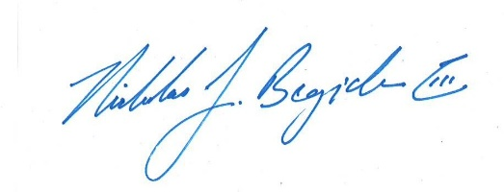

Nicholas J. Begich III

Congressman for All Alaska