May 23, 2025

|  |  |
| --- | --- |
| The Honorable Chairman Cole  Chairman, House Committee on  Appropriations  U.S. House of Representatives  Washington, DC 20515 | The Honorable Ranking Member DeLauro  Ranking Member, House Committee on  Appropriations  U.S. House of Representatives  Washington, DC 20515 |

Dear Chairman Cole and Ranking Member DeLauro,

I am requesting funding for City of Unalaska - Captains Bay Road in Fiscal Year 2026. The entity to receive funding for this project is the City of Unalaska, located at 43 Raven Way P.O. Box 610, Unalaska, AK, 99685.

This funding would be used for roadway realignment, utility extension and installation, drainage improvements, lighting, walkways and pavement for Captains Bay Road, a gravel road that serves as the primary transportation route for Westward Seafoods, Alaska Chadux Network, North Pacific Fuel, Trident Seafoods, Alaska Marine Lines, Offshore Systems Inc., Bering Shai Rock and Gravel, and other small businesses and residences.

The project is an appropriate use of taxpayer funds as it will improve a critical corridor for pedestrians as well as heavy trucks in the fishing, shipping, and support industries vital to Unalaska’s economy. Unalaska is the largest commercial fishing port by volume in the United States, with Captains Bay Road a key part of the infrastructure needed for the delivery of seafood to the lower 48 States, Asia, Canada and elsewhere in the world.

The project has a federal nexus because the funding provided is for purposes authorized by 23 USC 133. I certify that I have no financial interest in this project, and neither does anyone in my immediate family.

Sincerely,

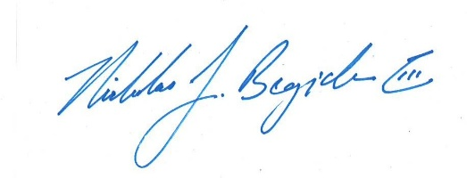

Nicholas J. Begich III

Congressman for All Alaska